 | 12.1.70 Editors - Geometry Nodes Editor - Header - Add Menu - Geometry Nodegroups - Mesh - Read
Table of content
Detailed table of content 1
Add menu - Geometry nodes - Mesh - Read 1
Edge Length 2
Face Corner Angle 2
Is Edge Boundary 2
Is Edge Loose 2
Is Edge Manifold 3
Is UV Split 3

Detailed table of content
Detailed table of content
Detailed table of content 1
Add menu - Geometry nodes - Mesh - Read 1
Edge Length 2
Face Corner Angle 2
Is Edge Boundary 2
Is Edge Loose 2
Is Edge Manifold 3
Is UV Split 3

Add menu - Geometry nodes - Mesh - Read

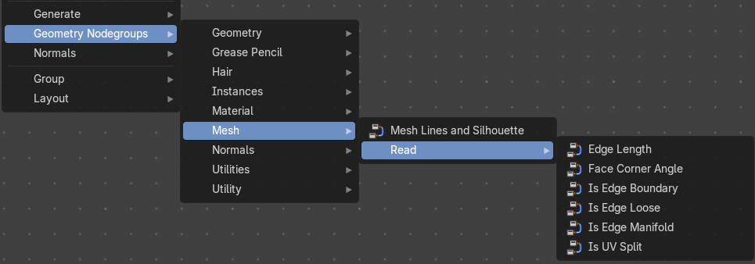
The nodes in this submenu are node groups. They use the regular single nodes under the hood.
It is virtually impossible to document these nodes in detail. So we will just list them.
When you double click the header, then you will enter the first level of the group. When you then press tab, or click again at the header, then you will reach the single nodes.




To leave the group you can use the breadcrumb up left in the header. These breadcrumbs are clickable. Or the Parent Node Tree button up right in the header.

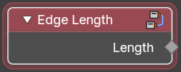
Edge Length
Returns the length of an edge.

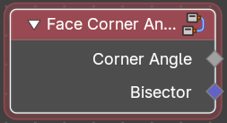
Face Corner Angle
Returns the angle between two edges.

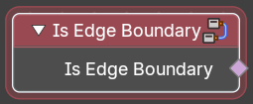
Is Edge Boundary
Returns a selection of boundary edges.

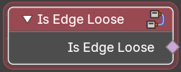
Is Edge Loose
Returns a selection of loose edges.

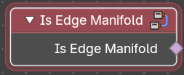
Is Edge Manifold
Returns a selection of manifold edges.

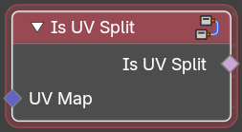
Is UV Split
Returns a selection of seam edges at the border of UV patches.

